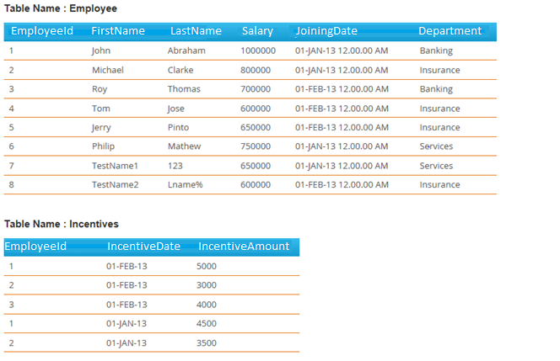

Employee.EmployeeId links to Incentives.EmployeeId

**Table: Employee**EmployeeId INT  
FirstName VARCHAR(50)  
LastName VARCHAR(50)  
Salary INT  
JoiningDate DATETIME  
Department VARCHAR(100)

**Table: Incentives**EmployeeId INT  
IncentiveDate DATETIME  
IncentiveAmount INT

We are looking for general understanding of SQL concepts/techniques and are not concerned with precise syntax for this test. If you’re not sure of the syntax, you can even write pseudo code.   
Skip any questions you quickly get stuck on, but go back to them if you have time.

All the questions have a single-set solution.

For any questions (or parts of questions), for which you think you know the concept but can’t remember key words, please write one or more examples of what you would initially google.

For this test, you may use Select * where no specific columns are requested.  
If you have time remaining and have questions for which you have no single-statement solution, write or describe a multi-statement solution.

**1. Display all unique Department names from the Employee table.**

*Select distinct Department from Employee***2. Display unique departments from the Employee table, listing the number of employees under each Department and order the departments alphabetically**

*Select distinct Department,count(1) from Employee group by Department order by Department***3. Display the first 3 characters of FirstName from the Employee table**

*Select substr(FirstName,1,3) from Employee*

**4. Concatenate FirstName and LastName as a single column from employee table separated by '_' and labeled ‘FullName’. Assume there can be NULL values in either FirstName or LastName.**

*Select replace (Isnull(FirstName,’_’ + ’_’ + Isnull(LastName,’_’),’__’,’’) as FullName from Employee*

**5. Get all employee details from the employee table, order by Salary descending and then FirstName ascending.**

*Select * from Employee order by Salary desc, FirstName ascending*

**6. Display all employee details from employee table where FirstName is “John” or “Roy”.**

*Select * from Employee where FirstName in( ‘John’ ,‘Roy’)*

**7. Display all employee details from employee table whose FirstName starts with 'J'.**

*Select * from Employee where FirstName like ‘J%’*

**8. Display all employee details from employee table where Salary is between 500,000 and 800,000 inclusive.**

*Select * from Employee where Salary between 500000 and 800000*

**9. Display all employee details from Employee table where joined before 1st January 2013.**

*Select * from Employee where JoiningDate < ’01-Jan-2013’*

**10. Display all LastName, FirstName, IncentiveDate, IncentiveAmount and differences in days between JoiningDate and IncentiveDate(s) per employee, order by LastName,FirstName and IncentiveDate (all ascending).**

*Select e.LastName, e.FirstName,i. IncentiveDate, i.IncentiveAmount from Employee e, right outer join Incentive i on e.employeeId = i.employeeId and e.JoiningDate <> i.IncentiveDate*

**11. Display Department, total Salary by department from the Employee table.**

*Select Department,sum(Salary) from Employee group by Department*

**12. Display Department and total Salary for all departments recorded in the Employee table, order by total Salary descending**

*Select Department,sum(Salary) as total_Sal from Employee group by Department order by total_Sal*

**13. Display, per Department, the maximum Salary from the Employee table, order by salary ascending.**

*Select distinct Department*

*, (select max(Salary) from Employee E1where E1.EmployeeId E.EmployeeId)*

*as Max_Sal*

*from Employee E order by Max_Sal asc*

**14. Display the number of employees joining by year and month**

*Select to_char(JoiningDate,’MM’) as Month, to_char(JoiningDate,’YYYY’) as Year, count(1) as No_Emps from Employee group by Month,Year*

**15. Display Salary totals by Department, but only for Departments where the total is greater 800,000.**

*Select Department,sum(Salary) total_Sal from Employee group by Department having sum(Salary)> 800000*

**16. Update IncentiveAmount to 9,000 for Employee(s) named 'John'. Use a join, not a subquery.**

*Update Incentives*

*set*

*Incentives.IncentiveAmount = 9000*

*From Incentives I*

*Inner join Employee E*

*on I. EmployeeId = E. EmployeeId and E.LastName = 'John'*

**17. Select FirstName, IncentiveAmount from the Employee table and Incentives table for those employees who have incentives.**

*Select E.FirstName, I.IncentiveAmount*

*from Employee E right outer Incentives I on E.EmployeeId = I.EmployeeId*

**18. Select FirstName, IncentiveAmount for incentive amounts greater than 3,000** .

*Select FirstName from Employee E where exists (select 1 from incentive I where I.EmployeeId = E.EmployeeId and I.IncentiveAmount > 3000)*

**19. Display FirstName, IncentiveAmount from the Employee table and Incentives table for all employees even if they didn't get incentives, and return incentive amount as 0 for those employees who do not have incentives.**

*Select E.FirstName, isnull(I.IncentiveAmount ,0)*

*from Employee E full outer Incentives I on E.EmployeeId = I.EmployeeId*

**20. Select only the 2nd Highest salary amount from employee table (selecting a tie amount is ok)**.

*Select max(salary) from Employee where salary <> (Select max(salary) from Employee)*

**21. Display all FirstName and LastName from the Employee table as separate rows in a single column labeled ‘NamePart’.**

*Select* ***FirstName as NamePart from Employee***

***Union all***

*Select* ***LastName as NamePart from Employee***